

  Project 2020

**Authors:**

Raya Stanislav Lilova

* Email: [RSLilova18@codingburgas.bg](mailto:RSLilova18@codingburgas.bg)
* School: Vocational High School for Computer Programming and Innovation
* Class: IX G class

Stivan Stanislav Lilov

* Email: SSLilov18@codingburgas.bg
* School: Vocational High School for Computer Programming and Innovation
* Class: IX G class

Boyan Grigorov Binev

* Email: BGBinev18@codingburgas.bg
* School: Vocational High School for Computer Programming and Innovation
* Class: IX V class

Radoslav Milenov Ivanov

* Email:  [RMIvanov18@codingburgas.bg](mailto:RMIvanov18@codingburgas.bg)
* School: Vocational High School for Computer Programming and Innovation

Class: IX A class

Kaloyan Dimitrov Dimov

* Email: [KDDimov18@codingburgas.bg](mailto:KDDimov18@codingburgas.bg)
* School: Vocational High School for Computer Programming and Innovation

Class: IX B class

Teachers:

Mariana Encheva - Lecturer in Information Technology and Informatics

* Email: [mencheva@codingburgas.bg](mailto:mencheva@codingburgas.bg)

Dimitrina Todorova - Lecturer in Information Technology and Informatics

* Email: dtodorova@codingburgas.bg

Petar Georgiev - Lecturer in Information Technology and Informatics

* Email: [pgeorgiev@codingburgas.bg](mailto:pgeorgiev@codingburgas.bg)

3.2 **Purpose**

The purpose of the project is to create a small quiz, and you have to answer questions to check your level in English

3.3 **Menu.**

* Start test
* Submit test
* Exit

Awareness raising for learning any language is aimed at:

1. prove to yourself that you can
2. Тo reconsider their English skills
3. Motivating more visitors to start studying English.

 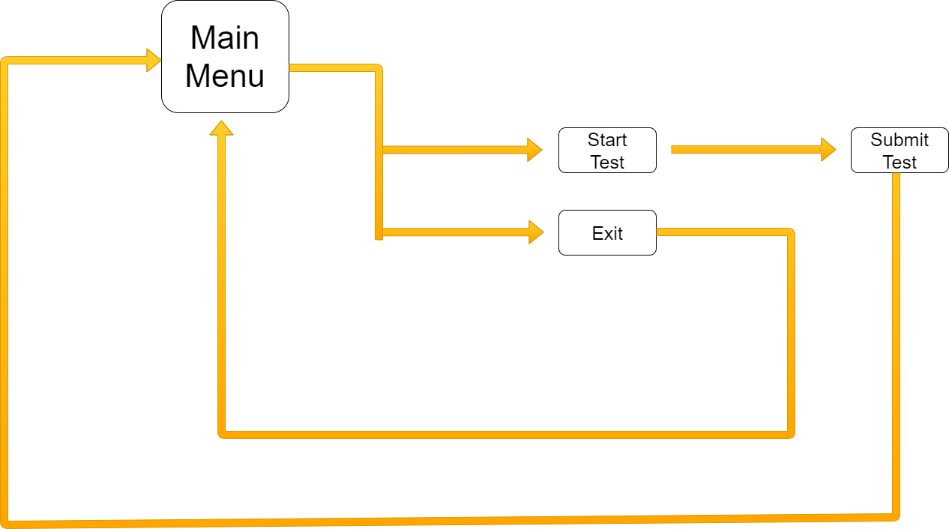   
 

Authors:

Raya Lilova

Stivan Lilov

Boyan Binev

Radoslav Ivanov

Kaloyan Dimov